Www. rstudio.com

> library(datasets) [Load the iris dataset]

> data("iris")

> names(iris)

[1] "Sepal.Length" "Sepal.Width" "Petal.Length" "Petal.Width" "Species"

> dim(iris)

[1] 150 5

> View(iris)

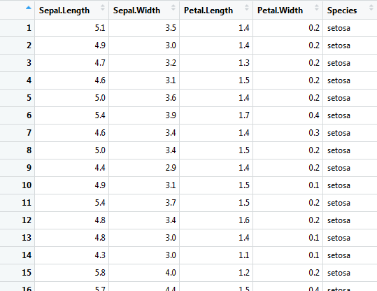

> str(iris)
'data.frame': 150 obs. of 5 variables:
$ Sepal.Length: num 5.1 4.9 4.7 4.6 5 5.4 4.6 5 4.4 4.9 ...
$ Sepal.Width : num 3.5 3 3.2 3.1 3.6 3.9 3.4 3.4 2.9 3.1 ...
$ Petal.Length: num 1.4 1.4 1.3 1.5 1.4 1.7 1.4 1.5 1.4 1.5 ...
$ Petal.Width : num 0.2 0.2 0.2 0.2 0.2 0.4 0.3 0.2 0.2 0.1 ...
$ Species : Factor w/ 3 levels "setosa","versicolor",..: 1 1 1 1 1 1 1 1 1 1 ...

> min(iris$Sepal.Length)

[1] 4.3

> max(iris$Sepal.Length)

[1] 7.9

> mean(iris$Sepal.Length)

[1] 5.843333

> range(iris$Sepal.Length)

[1] 4.3 7.9

> sd(iris$Sepal.Length)

[1] 0.8280661

/*Variance measures how far a set of data is spread out. A variance of zero indicates that all of the data values are identical. ... A high variance indicates that the data points are very spread out from the mean, and from one another. Variance is the average of the squared distances from each point to the mean.*/

> var(iris$Sepal.Length)

[1] 0.6856935

> summary(iris)
Sepal.Length Sepal.Width Petal.Length Petal.Width Species
Min. :4.300 Min. :2.000 Min. :1.000 Min. :0.100 setosa :50
1st Qu.:5.100 1st Qu.:2.800 1st Qu.:1.600 1st Qu.:0.300 versicolor:50
Median :5.800 Median :3.000 Median :4.350 Median :1.300 virginica :50
Mean :5.843 Mean :3.057 Mean :3.758 Mean :1.199
3rd Qu.:6.400 3rd Qu.:3.300 3rd Qu.:5.100 3rd Qu.:1.800
Max. :7.900 Max. :4.400 Max. :6.900 Max. :2.500

> summary(iris$Sepal.Length)

Min. 1st Qu. Median Mean 3rd Qu. Max.
4.300 5.100 5.800 5.843 6.400 7.900

/*A quantile, or percentile, tells you how much of your data lies below a certain value. The 50 percent quantile, for example, is the same as the median. */

> quantile(iris$Sepal.Length)

0% 25% 50% 75% 100%
4.3 5.1 5.8 6.4 7.9

>quantile(iris$Sepal.Length,c(0.3, 0.6))

30% 60%
5.27 6.10

> hist(iris$Petal.Length)

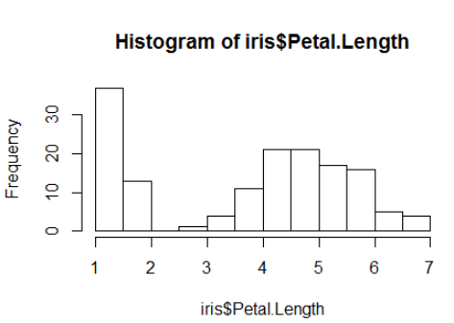

h<-hist(iris$Sepal.Length,main= "sepal length frequency- histogram", xlab="sepal length", xlim=c(3.5,8.5), col="blue",border = "red",breaks =5)
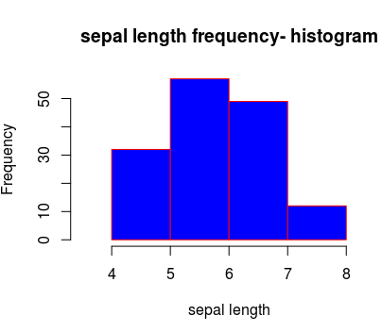

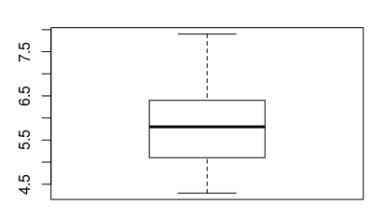
> boxplot(iris$Sepal.Length)

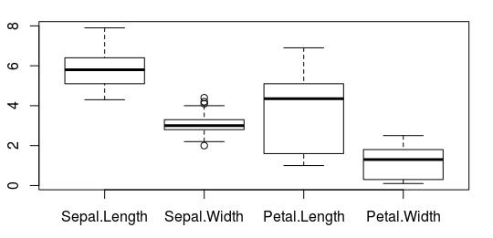

>boxplot(iris[,-5])

> myboxplot<-boxplot(iris[,-5])

// Return subsets of vectors, matrices or data frames which meet conditions.
> irisVer <- subset(iris, Species == "versicolor")
> irisSet <- subset(iris, Species == "setosa")
> irisVir <- subset(iris, Species == "virginica")

//We can put multiple graphs in a single plot by setting some graphical parameters with the help of par() function. Graphical parameter mfrow can be used to specify the number of subplot we need.It takes in a vector of form c(m, n) which divides the given plot into m*n array of subplots.
mar is used to set the coordinates in a normalized form as c(x1, x2, y1, y2)

> par(mfrow=c(1,4),mar=c(6,3,2,1))

> boxplot(irisVer[,1:4], main="Versicolor",ylim = c(0,8),las=2)

> boxplot(irisSet[,1:4], main="Setosa",ylim = c(0,8),las=2)

> boxplot(irisVir[,1:4], main="Virginica",ylim = c(0,8),las=2)
